UML Assignment

Class Diagram for Airline Reservation system

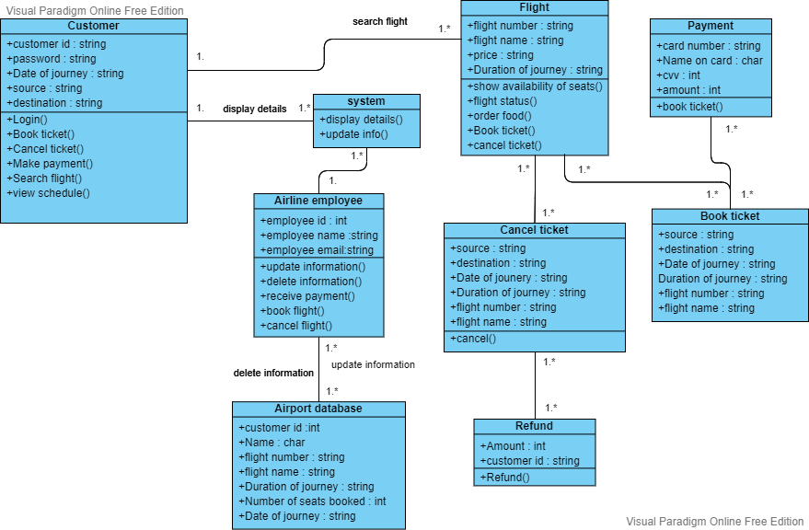

Class Diagram for University Department

Activity Diagram for University Enrolment

Sequence Diagram form Online Library Management system

